

**School of computer application**

CA First

of

Big Data (CAP 457)

**Session 2022-2024**

**Submitted to: Submitted by:**

Name: Dr. Kala K U Name: Satyam Mishra

(Dept of. Computer Science) Reg. no: 12212256

Course: MCA

**Department of computer Science**

**Lovely Professional University Jalandhar Punjab (144401)**

**India.**

**Screenshots**

1. **Creating table named as student**

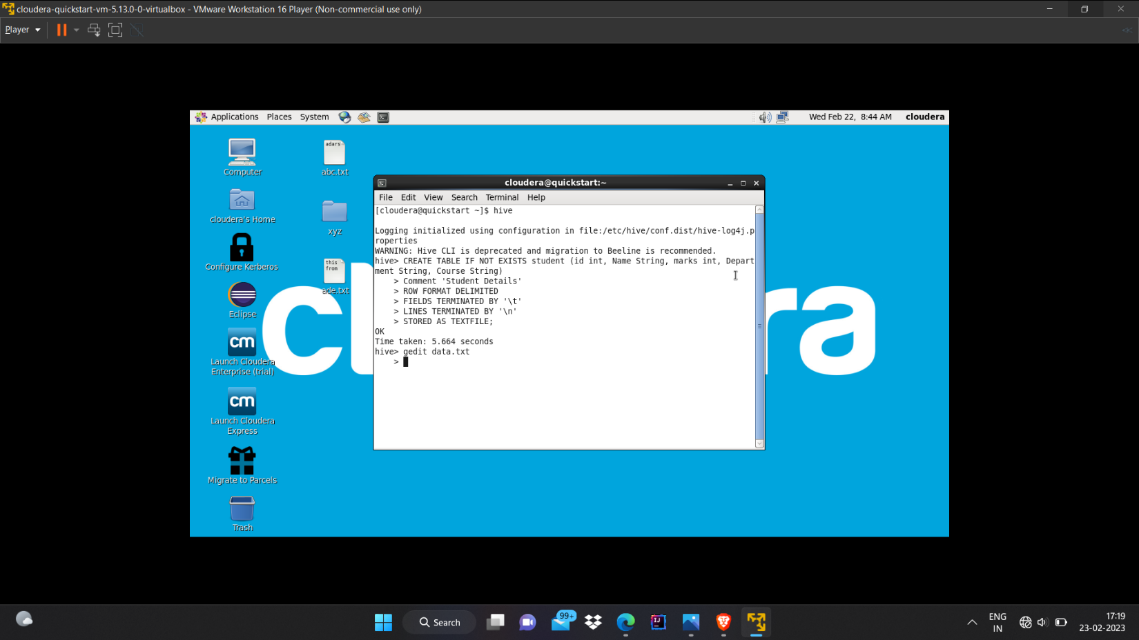

1. **Create a file named as data and upload it to the table**

1. **Show the content of the table**

1. A screenshot of a computer

   Description automatically generated**Rename the table name as std.**